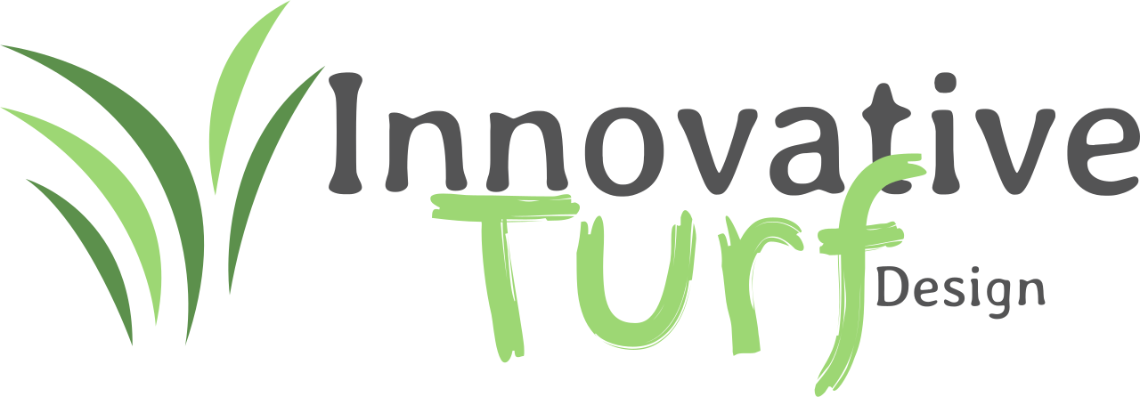

# Capabilities Statement

## Innovative Turf Design

Experts in Artificial Turf Installation, Drainage & Xeriscape Solutions.

## Company Overview

Innovative Turf Design is a premier provider of high-quality artificial turf installation for residential, commercial, municipal, and recreational applications. With a commitment to durability, aesthetics, and customer satisfaction, we deliver innovative turf solutions tailored to meet the unique needs of each client.

## Core Competencies

* Artificial Turf Installation
* - Residential lawns, backyards, and front yards
* - Commercial landscaping and property enhancement
* - Playgrounds and daycare surfaces
* - Dog parks and pet-friendly turf systems
* - Athletic fields and sports facilities
* Turf Removal & Replacement
* Base Preparation and Grading
* Hardscape Integration
* - Pavers, edging, retaining walls
* Drainage Systems & Weed Barriers
* Maintenance Services
* - Cleaning, infill replenishment, and repairs

## Differentiators

* Highly skilled, in-house installation team
* Custom design consultations
* Premium, eco-friendly turf products with UV protection and cooling technology
* Fast turnaround times with project timelines consistently met
* Competitive pricing and price-match guarantee
* 5–15 year product warranties depending on application
* Fully licensed, bonded, and insured

## Past Performance

* Residential Community Projects – Full yard makeovers in HOA-regulated neighborhoods
* Schools & Playgrounds – Safe, durable turf installations with shock-absorbent padding
* Veterinary Clinics & Dog Parks – Pet-safe installations with antimicrobial infill
* Commercial Properties – Professional curb appeal enhancements

## Company Data

* Business Name: Innovative Turf Design
* DUNS: [if applicable]
* CAGE Code: 12PV1
* NAICS Codes: 561730 (Landscaping Services), 238990 (Specialty Trade Contractors)
* Business Structure: LLC, Corporation,
* Location: Montgomery, Tx, Tomball,Tx
* Service Area: Gulf Coast Region

## Contact Information

Mandy Hoffman

Title: Owner

Phone: 832-776-9269

Email: info@txitd.com

Website: www.txitd.com

Social: https://www.facebook.com/txitd

## Project Showcase

Here's a highlight from one of our premium turf installations:

